Docker – Overview

Docker – Use

Docker – Installation

Docker – Terms

Docker – Container

Docker – Images

Docker – Hub/Registry

Docker – Jenkins Image in Docker container

Docker – Overview

Docker is a **container management service**. The keywords of Docker are **develop, ship** and **run** anywhere. The whole idea of Docker is for developers to easily develop applications, ship them into containers which can then be deployed anywhere.

The initial release of Docker was in March 2013 and since then, it has become the buzzword for modern world development, especially in the face of Agile-based projects.

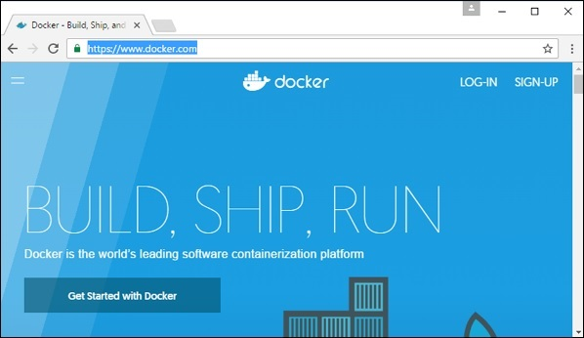

## Features of Docker

* Docker has the ability to **reduce the size of development by providing a smaller footprint** of the operating system via containers.
* With containers, it becomes easier for teams across different units, such as **development, QA and Operations to work seamlessly across applications**.
* **You can deploy Docker containers anywhere, on any physical and virtual machines (win, linux, mac) and even on the cloud**.
* Since Docker containers are pretty lightweight, they are very easily scalable.

## Components of Docker

Docker has the following components

* **Docker for Mac** − It allows one to run Docker containers on the Mac OS.
* **Docker for Linux** − It allows one to run Docker containers on the Linux OS.
* **Docker for Windows** − It allows one to run Docker containers on the Windows OS.
* **Docker Engine** − It is used for building **Docker images** and creating Docker containers.
* **Docker Hub** − This is the **registry** which is used to **host various Docker images**.
* **Docker Compose(yml)/Dockerfile** − This is used to define applications using multiple Docker containers.

We will discuss all these components in detail in the subsequent chapters.

The official site for Docker is <https://www.docker.com/> The site has all information and documentation about the Docker software. It also has the download links for various operating systems.

# Installing Docker on Linux

To start the installation of Docker, we are going to use an Ubuntu instance. You can use Oracle Virtual Box to setup a virtual Linux instance, in case you don’t have it already.

The following screenshot shows a simple Ubuntu server which has been installed on Oracle Virtual Box. There is an OS user named **demo** which has been defined on the system having entire root access to the sever.

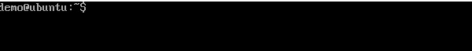

To install Docker, we need to follow the steps given below.

**Step 1** − Before installing Docker, you first have to ensure that you have the right Linux kernel version running. Docker is only designed to run on Linux kernel version 3.8 and higher. We can do this by running the following command.

### uname

This method returns the system information about the Linux system.

### Syntax

uname -a

### Options

**a** − This is used to ensure that the system information is returned.

### Return Value

This method returns the following information on the Linux system −

* kernel name
* node name
* kernel release
* kernel version
* machine
* processor
* hardware platform
* operating system

### Example

uname –a

### Output

When we run above command, we will get the following result −

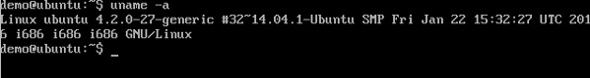

From the output, we can see that the Linux kernel version is 4.2.0-27 which is higher than version 3.8, so we are good to go.

**Step 2** − You need to update the OS with the latest packages, which can be done via the following command −

apt-get

yum

rpm

This method installs packages from the Internet on to the Linux system.

### Syntax

sudo apt-get update

### Options

* **sudo** − The **sudo** command is used to ensure that the command runs with root access.
* **update** − The **update** option is used ensure that all packages are updated on the Linux system.

### Return Value

None

### Example

sudo apt-get update

### Output

When we run the above command, we will get the following result −

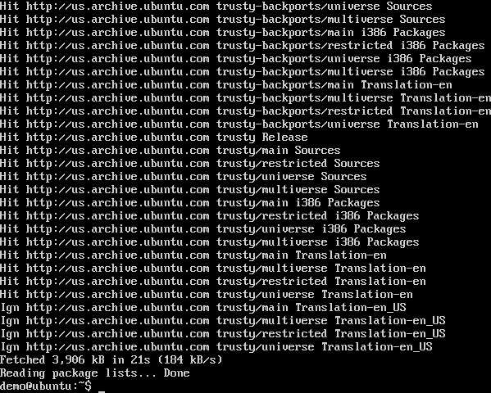

This command will connect to the internet and download the latest system packages for Ubuntu.

**Step 3** − The next step is to install the necessary certificates that will be required to work with the Docker site later on to download the necessary Docker packages. It can be done with the following command.

sudo apt-get install apt-transport-https ca-certificates

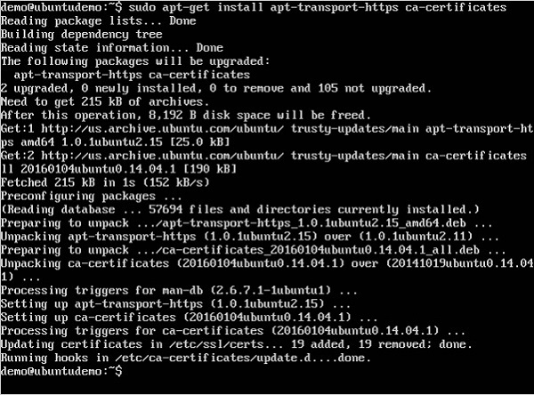

**Step 4** − The next step is to add the new GPG key. This key is required to ensure that all data is encrypted when downloading the necessary packages for Docker.

The following command will download the key with the ID 58118E89F3A912897C070ADBF76221572C52609D from the **keyserver**hkp://ha.pool.sks-keyservers.net:80 and adds it to the **adv** keychain. Please note that this particular key is required to download the necessary Docker packages.

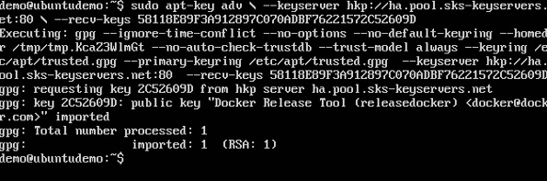

**Step 5** − Next, depending on the version of Ubuntu you have, you will need to add the relevant site to the **docker.list** for the **apt package manager**, so that it will be able to detect the Docker packages from the Docker site and download them accordingly.

* Precise 12.04 (LTS) ─ deb [https://apt.dockerproject.org/repo](https://apt.dockerproject.org/repo/)ubuntu-precise main
* Trusty 14.04 (LTS) ─ deb <https://apt.dockerproject.org/repo/>ubuntu-trusty main
* Wily 15.10 ─ deb [https://apt.dockerproject.org/repo](https://apt.dockerproject.org/repo/) ubuntu-wily main
* Xenial 16.04 (LTS) - [https://apt.dockerproject.org/repo](https://apt.dockerproject.org/repo/) ubuntu-xenial main

Since our OS is Ubuntu 14.04, we will use the Repository name as “deb [https://apt.dockerproject.org/repo](https://apt.dockerproject.org/repo/)ubuntu-trusty main”.

And then, we will need to add this repository to the **docker.list** as mentioned above.

echo "deb https://apt.dockerproject.org/repo ubuntu-trusty main”

| sudo tee /etc/apt/sources.list.d/docker.list

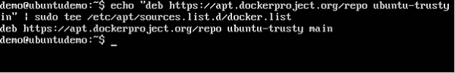

**Step 6** − Next, we issue the **apt-get update command** to update the packages on the Ubuntu system.

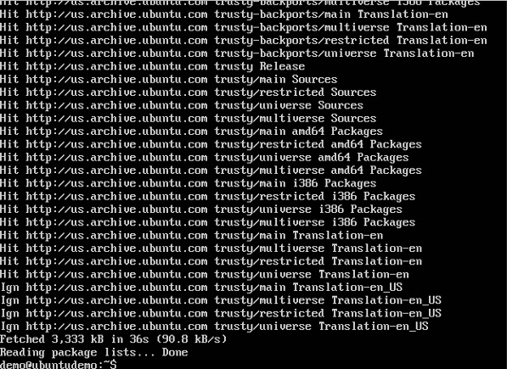

**Step 7** − If you want to verify that the package manager is pointing to the right repository, you can do it by issuing the **apt-cache command**.

apt-cache policy docker-engine

In the output, you will get the link to <https://apt.dockerproject.org/repo/>



**Step 8** − Issue the **apt-get update command** to ensure all the packages on the local system are up to date.

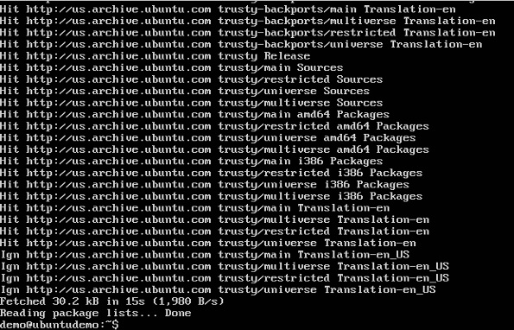

**Step 9** − For Ubuntu Trusty, Wily, and Xenial, we have to install the linux-image-extra-* kernel packages, which allows one to use the **aufs storage driver**. This driver is used by the newer versions of Docker.

It can be done by using the following command.

sudo apt-get install linux-image-extra-$(uname -r)

linux-image-extra-virtual

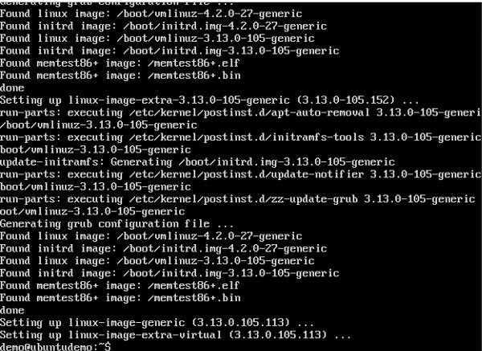

**Step 10** − The final step is to install Docker and we can do this with the following command −

sudo apt-get install –y docker-engine

Here, **apt-get** uses the install option to download the Docker-engine image from the Docker website and get Docker installed.

The Docker-engine is the official package from the Docker Corporation for Ubuntu-based systems.

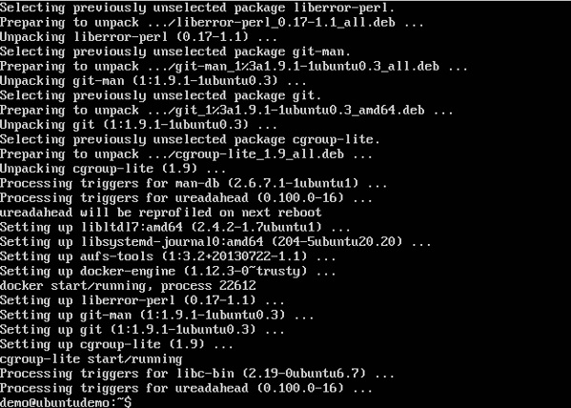

In the next section, we will see how to check for the version of Docker that was installed.

## Docker Version

To see the version of Docker running, you can issue the following command −

### Syntax

docker version

### Options

* **version** − It is used to ensure the Docker command returns the Docker version installed.

### Return Value

The output will provide the various details of the Docker version installed on the system.

### Example

sudo docker version

### Output

When we run the above program, we will get the following result −

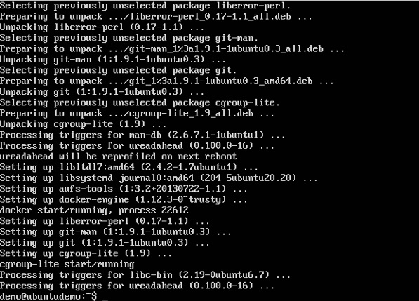

## Docker Info

To see more information on the Docker running on the system, you can issue the following command −

### Syntax

docker info

### Options

* **info** − It is used to ensure that the Docker command returns the detailed information on the Docker service installed.

### Return Value

The output will provide the various details of the Docker installed on the system such as −

* Number of containers
* Number of images
* The storage driver used by Docker
* The root directory used by Docker
* The execution driver used by Docker

### Example

sudo docker info

### Output

When we run the above command, we will get the following result −

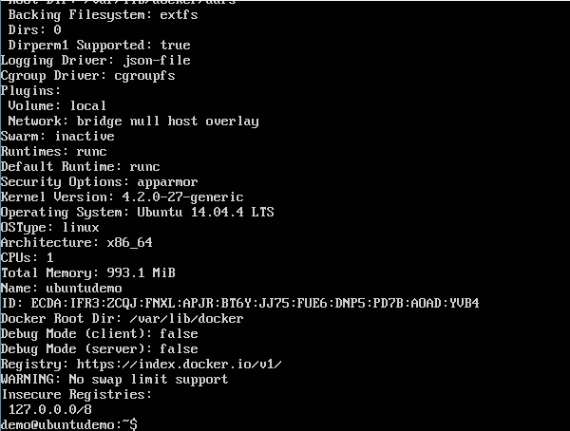

## Docker for Windows

Docker has out-of-the-box support for Windows, but you need to have the following configuration in order to install Docker for Windows.

### System Requirements

|  |  |
| --- | --- |
| Windows OS | Windows 10 64 bit |
| Memory | 2 GB RAM (recommended) |

You can download Docker for Windows from − <https://docs.docker.com/docker-for-windows/>

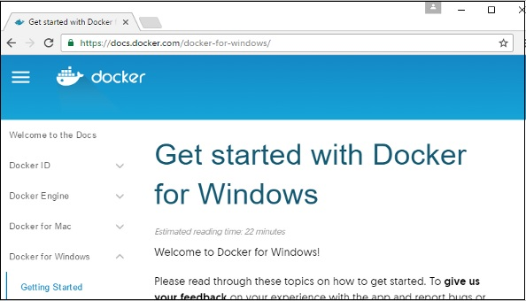

## Docker ToolBox

Docker ToolBox has been designed for older versions of Windows, such as Windows 8.1 and Windows 7. You need to have the following configuration in order to install Docker for Windows.

### System Requirements

|  |  |
| --- | --- |
| Windows OS | Windows 7 , 8, 8.1 |
| Memory | 2 GB RAM (recommended) |
| Virtualization | This should be enabled. |

You can download Docker ToolBox from − <https://www.docker.com/products/docker-toolbox>

# Docker Toolbox

# Docker – Installation

## Docker for Windows

Once the installer has been downloaded, double-click it to start the installer and then follow the steps given below.

**Step 1** − Click on the Agreement terms and then the Install button to proceed ahead with the installation.

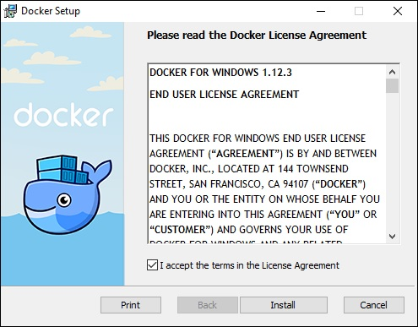

**Step 2** − Once complete, click the Finish button to complete the installation.

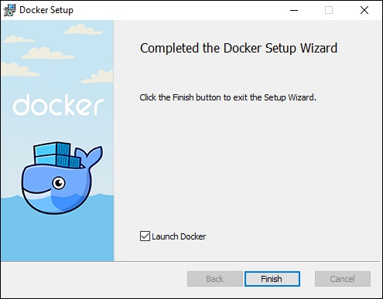

## Docker ToolBox

Once the installer has been downloaded, double-click it to start the installer and then follow the steps given below.

**Step 1** − Click the Next button on the start screen.

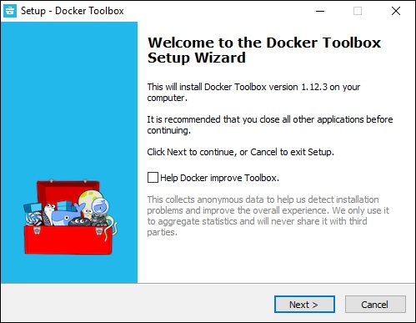

**Step 2** − Keep the default location on the next screen and click the Next button.

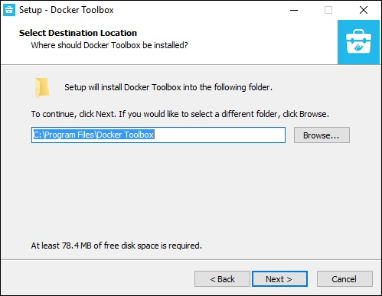

**Step 3** − Keep the default components and click the Next button to proceed.

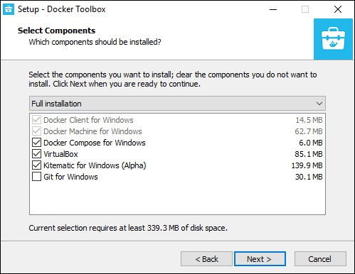

**Step 4** − Keep the Additional Tasks as they are and then click the Next button.

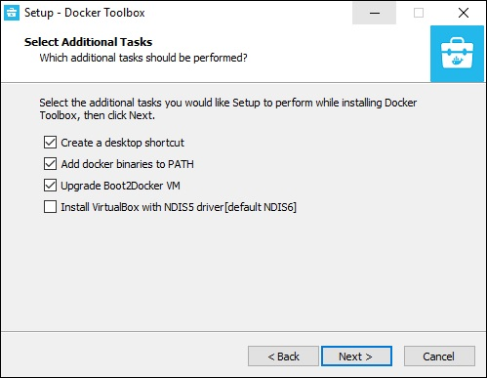

**Step 5** − On the final screen, click the Install button.

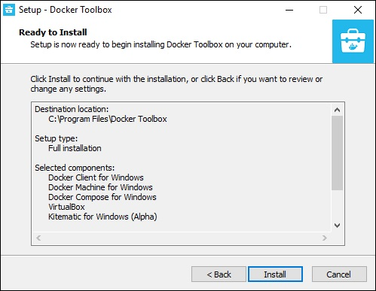

## Working with Docker Toolbox

Let’s now look at how Docker Toolbox can be used to work with Docker containers on Windows. The first step is to launch the Docker Toolbox application for which the shortcut is created on the desktop when the installation of Docker toolbox is carried out.

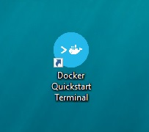

Next, you will see the configuration being carried out when Docker toolbox is launched.

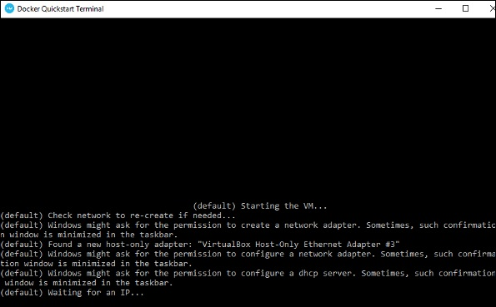

Once done, you will see Docker configured and launched. You will get an interactive shell for Docker.

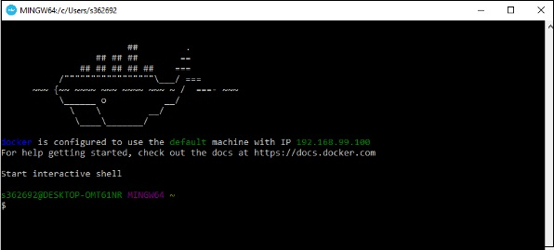

To test that Docker runs properly, we can use the Docker **run command** to download and run a simple **HelloWorld Docker container**.

The working of the Docker **run command** is given below −

docker run

This command is used to run a command in a Docker container.

### Syntax

docker run image

### Options

* **Image** − This is the name of the image which is used to run the container.

### Return Value

The output will run the command in the desired container.

### Example

sudo docker run hello-world

This command will download the **hello-world** image, if it is not already present, and run the **hello-world** as a container.

### Output

When we run the above command, we will get the following result −

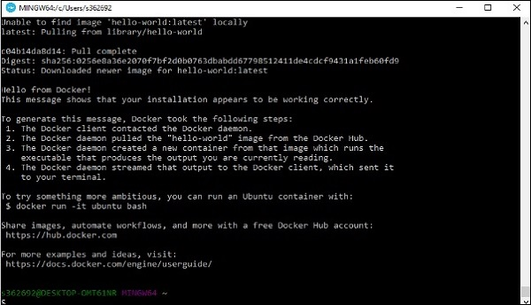

If you want to run the Ubuntu OS on Windows, you can download the Ubuntu Image using the following command −

Docker run –it Ubuntu bash

Here you are telling Docker to run the command in the interactive mode via the **–it** option.

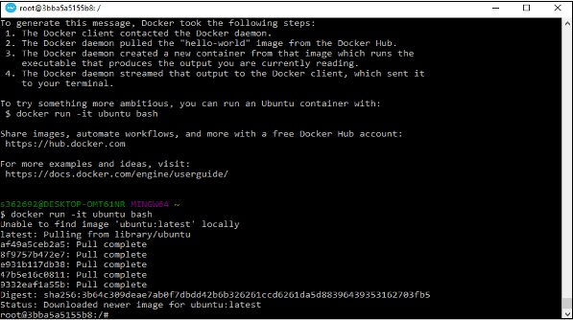

In the output you can see that the Ubuntu image is downloaded and run and then you will be logged in as a root user in the Ubuntu container.

# Docker – Hub

Docker Hub is a registry service on the cloud that allows you to download Docker images that are built by other communities. You can also upload your own Docker built images to Docker hub. In this chapter, we will see how to download and the use the Jenkins Docker image from Docker hub.

The official site for Docker hub is − <https://www.docker.com/community-edition#/add_ons>

**Step 1** − First you need to do a simple sign-up on Docker hub.

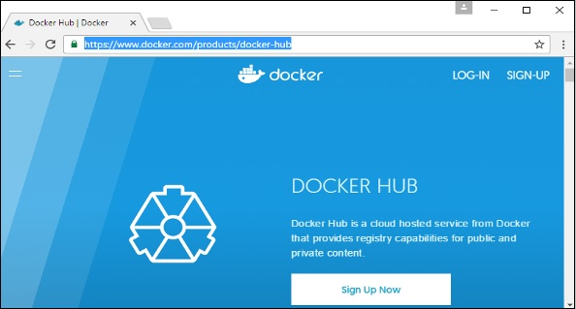

**Step 2** − Once you have signed up, you will be logged into Docker Hub.

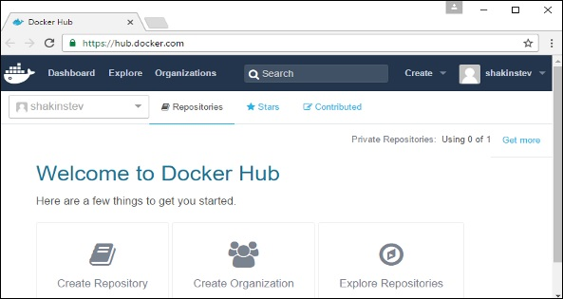

**Step 3** − Next, let’s browse and find the Jenkins image.

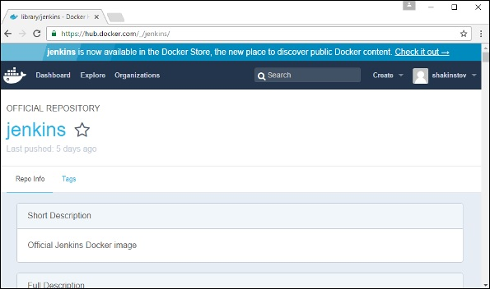

**Step 4** − If you scroll down on the same page, you can see the Docker **pull** command. This will be used to download the Jenkins image onto the local Ubuntu server.

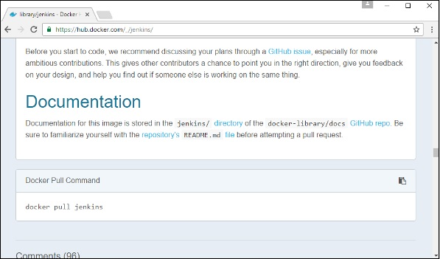

**Step 5** − Now, go to the Ubuntu server and run the following command −

sudo docker pull jenkins

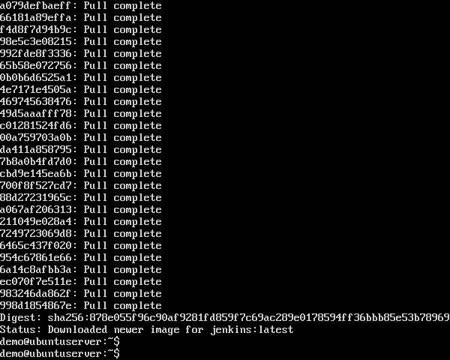

To run Jenkins, you need to run the following command −

sudo docker run -p 8080:8080 -p 50000:50000 jenkins

Note the following points about the above **sudo** command −

* We are using the **sudo** command to ensure it runs with root access.
* Here, **jenkins** is the name of the image we want to download from Docker hub and install on our Ubuntu machine.
* **-p** is used to map the port number of the internal Docker image to our main Ubuntu server so that we can access the container accordingly.

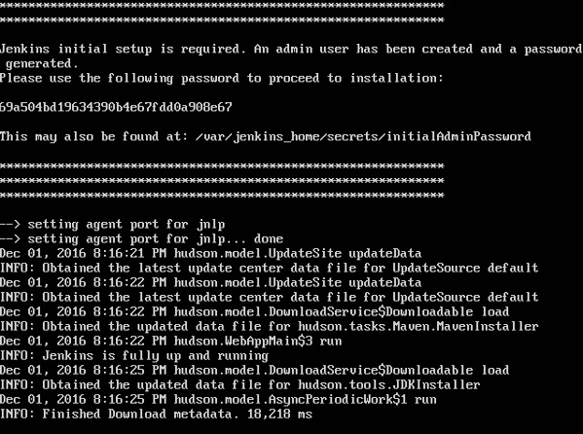

You will then have Jenkins successfully running as a container on the Ubuntu machine.

# Docker – Images

In Docker, everything is based on Images. An image is a combination of a file system and parameters. Let’s take an example of the following command in Docker.

docker run hello-world

* The Docker command is specific and tells the Docker program on the Operating System that something needs to be done.
* The **run** command is used to mention that we want to create an instance of an image, which is then called a **container**.
* Finally, "hello-world" represents the image from which the container is made.

Now let’s look at how we can use the CentOS image available in Docker Hub to run CentOS on our Ubuntu machine. We can do this by executing the following command on our Ubuntu machine −

sudo docker run centos –it /bin/bash

Note the following points about the above **sudo** command −

* We are using the **sudo** command to ensure that it runs with **root**access.
* Here, **centos** is the name of the image we want to download from Docker Hub and install on our Ubuntu machine.
* **─it** is used to mention that we want to run in **interactive mode**.
* **/bin/bash** is used to run the bash shell once CentOS is up and running.

## Displaying Docker Images

To see the list of Docker images on the system, you can issue the following command.

docker images

This command is used to display all the images currently installed on the system.

### Syntax

docker images

### Options

None

### Return Value

The output will provide the list of images on the system.

### Example

sudo docker images

### Output

When we run the above command, it will produce the following result −

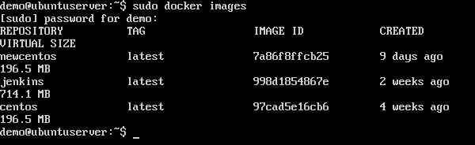

From the above output, you can see that the server has three images: **centos, newcentos,** and **jenkins**. Each image has the following attributes −

* **TAG** − This is used to logically tag images.
* **Image ID** − This is used to uniquely identify the image.
* **Created** − The number of days since the image was created.
* **Virtual Size** − The size of the image.

## Downloading Docker Images

Images can be downloaded from Docker Hub using the Docker **run** command. Let’s see in detail how we can do this.

### Syntax

The following syntax is used to run a command in a Docker container.

docker run image

### Options

* **Image** − This is the name of the image which is used to run the container.

### Return Value

The output will run the command in the desired container.

### Example

sudo docker run centos

This command will download the **centos** image, if it is not already present, and run the OS as a container.

### Output

When we run the above command, we will get the following result −

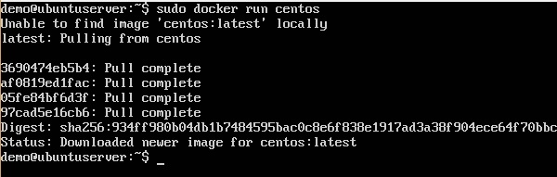

You will now see the CentOS Docker image downloaded. Now, if we run the Docker **images** command to see the list of images on the system, we should be able to see the **centos** image as well.

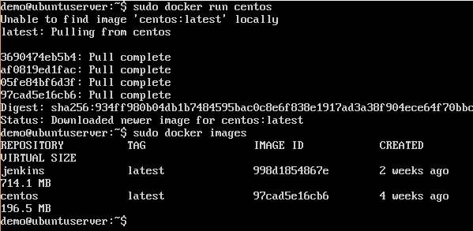

## Removing Docker Images

The Docker images on the system can be removed via the **docker rmi** command. Let’s look at this command in more detail.

docker rmi

This command is used to remove Docker images.

### Syntax

docker rmi ImageID

### Options

* **ImageID** − This is the ID of the image which needs to be removed.

### Return Value

The output will provide the Image ID of the deleted Image.

### Example

sudo docker rmi 7a86f8ffcb25

Here, **7a86f8ffcb25** is the Image ID of the **newcentos** image.

### Output

When we run the above command, it will produce the following result −

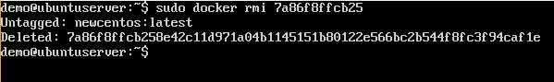

Let’s see some more Docker commands on images.

## docker images -q

This command is used to return only the Image ID’s of the images.

### Syntax

docker images

### Options

* **q** − It tells the Docker command to return the Image ID’s only.

### Return Value

The output will show only the Image ID’s of the images on the Docker host.

### Example

sudo docker images -q

### Output

When we run the above command, it will produce the following result −

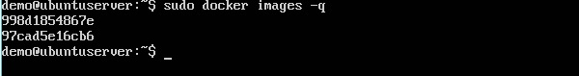

## docker inspect

This command is used see the details of an image or container.

### Syntax

docker inspect Repository

### Options

* **Repository** − This is the name of the Image.

### Return Value

The output will show detailed information on the Image.

### Example

sudo docker inspect jenkins

### Output

When we run the above command, it will produce the following result −

# Docker Inspect

# Docker - Containers

Containers are instances of Docker images that can be run using the Docker run command. The basic purpose of Docker is to run containers. Let’s discuss how to work with containers.

## Running a Container

Running of containers is managed with the Docker **run** command. To run a container in an interactive mode, first launch the Docker container.

sudo docker run –it centos /bin/bash

Then hit Crtl+p and you will return to your OS shell.

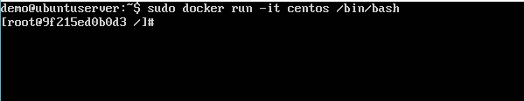

You will then be running in the instance of the CentOS system on the Ubuntu server.

## Listing of Containers

One can list all of the containers on the machine via the **docker ps** command. This command is used to return the currently running containers.

docker ps

### Syntax

docker ps

### Options

None

### Return Value

The output will show the currently running containers.

### Example

sudo docker ps

### Output

When we run the above command, it will produce the following result −

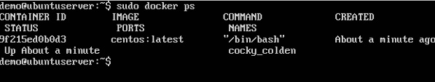

Let’s see some more variations of the **docker ps** command.

## docker ps -a

This command is used to list all of the containers on the system

### Syntax

docker ps -a

### Options

* **─a** − It tells the **docker ps** command to list all of the containers on the system.

### Return Value

The output will show all containers.

### Example

sudo docker ps -a

### Output

When we run the above command, it will produce the following result −

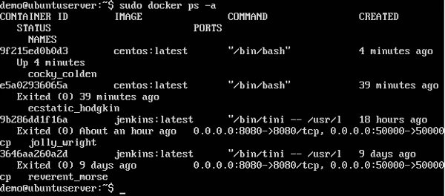

## docker history

With this command, you can see all the commands that were run with an image via a container.

### Syntax

docker history ImageID

### Options

* **ImageID** − This is the Image ID for which you want to see all the commands that were run against it.

### Return Value

The output will show all the commands run against that image.

### Example

sudo docker history centos

The above command will show all the commands that were run against the **centos** image.

### Output

When we run the above command, it will produce the following result −

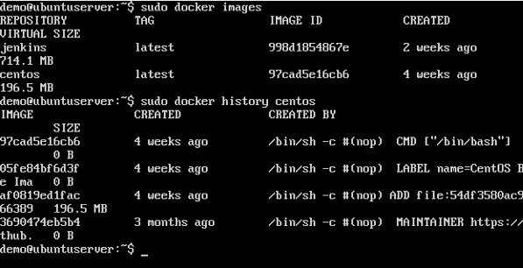

# Docker - Working with Containers

In this chapter, we will explore in detail what we can do with containers.

## docker top

With this command, you can see the top processes within a container.

### Syntax

docker top ContainerID

### Options

* **ContainerID** − This is the Container ID for which you want to see the top processes.

### Return Value

The output will show the top-level processes within a container.

### Example

sudo docker top 9f215ed0b0d3

The above command will show the top-level processes within a container.

### Output

When we run the above command, it will produce the following result −

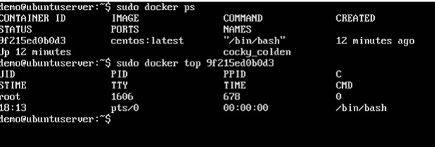

## docker stop

This command is used to stop a running container.

### Syntax

docker stop ContainerID

### Options

* **ContainerID** − This is the Container ID which needs to be stopped.

### Return Value

The output will give the ID of the stopped container.

### Example

sudo docker stop 9f215ed0b0d3

The above command will stop the Docker container **9f215ed0b0d3**.

### Output

When we run the above command, it will produce the following result −

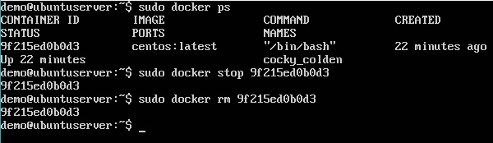

## docker rm

This command is used to delete a container.

### Syntax

docker rm ContainerID

### Options

* **ContainerID** − This is the Container ID which needs to be removed.

### Return Value

The output will give the ID of the removed container.

### Example

sudo docker rm 9f215ed0b0d3

The above command will remove the Docker container **9f215ed0b0d3**.

### Output

When we run the above command, it will produce the following result −

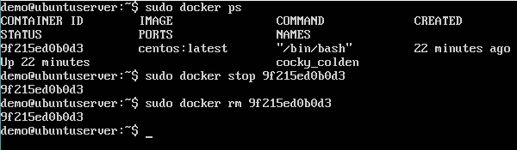

## docker stats

This command is used to provide the statistics of a running container.

### Syntax

docker stats ContainerID

### Options

* **ContainerID** − This is the Container ID for which the stats need to be provided.

### Return Value

The output will show the CPU and Memory utilization of the Container.

### Example

sudo docker stats 9f215ed0b0d3

The above command will provide CPU and memory utilization of the Container **9f215ed0b0d3**.

### Output

When we run the above command, it will produce the following result −

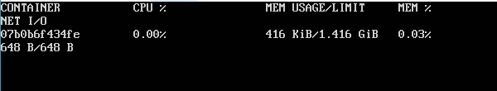

## docker attach

This command is used to attach to a running container.

### Syntax

Doker run –it imagename

Open new terminal

Docker container ps

Docker stats containerid

docker attach ContainerID

### Options

* **ContainerID** − This is the Container ID to which you need to attach.

### Return Value

None

### Example

sudo docker attach 07b0b6f434fe

The above command will attach to the Docker container **07b0b6f434fe**.

### Output

When we run the above command, it will produce the following result −

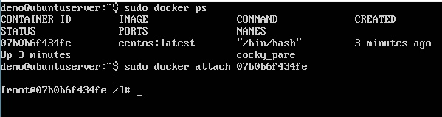

Once you have attached to the Docker container, you can run the above command to see the process utilization in that Docker container.

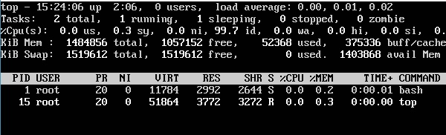

## docker pause

This command is used to pause the processes in a running container.

### Syntax

docker pause ContainerID

### Options

* **ContainerID** − This is the Container ID to which you need to pause the processes in the container.

### Return Value

The ContainerID of the paused container.

### Example

sudo docker pause 07b0b6f434fe

The above command will pause the processes in a running container **07b0b6f434fe**.

### Output

When we run the above command, it will produce the following result −

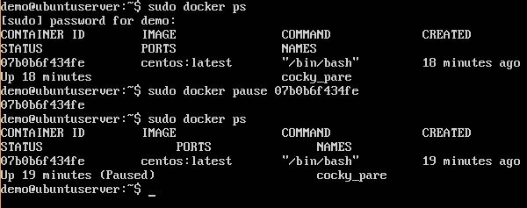

## docker unpause

This command is used to **unpause** the processes in a running container.

### Syntax

docker unpause ContainerID

### Options

* **ContainerID** − This is the Container ID to which you need to unpause the processes in the container.

### Return Value

The ContainerID of the running container.

### Example

sudo docker unpause 07b0b6f434fe

The above command will unpause the processes in a running container: 07b0b6f434fe

### Output

When we run the above command, it will produce the following result −

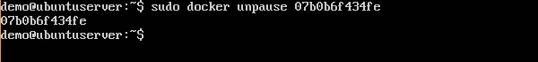

## docker kill

This command is used to kill the processes in a running container.

### Syntax

docker kill ContainerID

### Options

* **ContainerID** − This is the Container ID to which you need to kill the processes in the container.

### Return Value

The ContainerID of the running container.

### Example

sudo docker kill 07b0b6f434fe

The above command will kill the processes in the running container **07b0b6f434fe**.

### Output

When we run the above command, it will produce the following result −

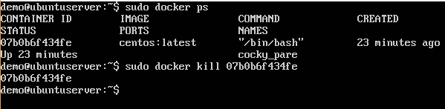

## Docker – Container Lifecycle

The following illustration explains the entire lifecycle of a Docker container.

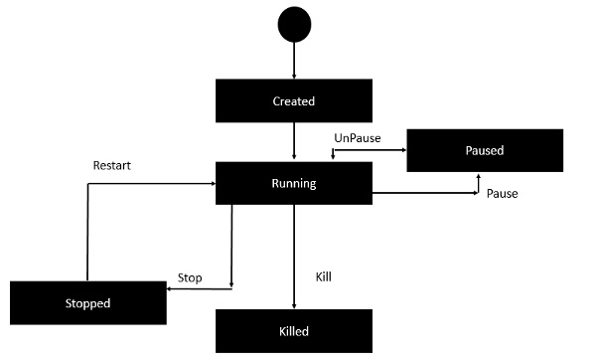

* Initially, the Docker container will be in the **created** state.
* Then the Docker container goes into the running state when the Docker **run** command is used.
* The Docker **kill** command is used to kill an existing Docker container.
* The Docker **pause** command is used to pause an existing Docker container.
* The Docker **stop** command is used to pause an existing Docker container.
* The Docker **run** command is used to put a container back from a **stopped** state to a **running** state.

# Docker - Architecture

The following image shows the standard and traditional architecture of **virtualization**.

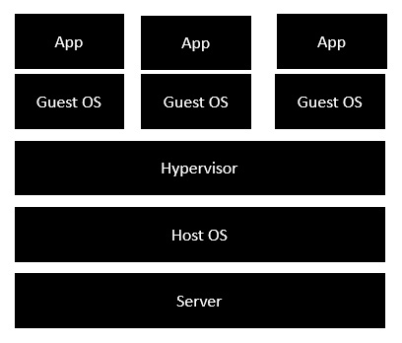

$docker run hello-world

$

$docker run –it hello-world

#

* The server is the physical server that is used to host multiple virtual machines.
* The Host OS is the base machine such as Linux or Windows.
* The Hypervisor is either VMWare or Windows Hyper V that is used to host virtual machines.
* You would then install multiple operating systems as virtual machines on top of the existing hypervisor as Guest OS.
* You would then host your applications on top of each Guest OS.

The following image shows the new generation of virtualization that is enabled via Dockers. Let’s have a look at the various layers.

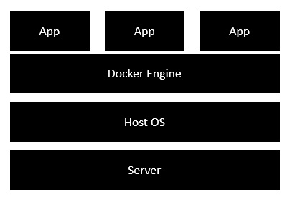

* The server is the physical server that is used to host multiple virtual machines. So this layer remains the same.
* The Host OS is the base machine such as Linux or Windows. So this layer remains the same.
* Now comes the new generation which is the Docker engine. This is used to run the operating system which earlier used to be virtual machines as Docker containers.
* All of the Apps now run as Docker containers.

The clear advantage in this architecture is that you don’t need to have extra hardware for Guest OS. Everything works as Docker containers.

# Docker - Container and Hosts

The good thing about the Docker engine is that it is designed to work on various operating systems. We have already seen the installation on Windows and seen all the Docker commands on Linux systems. Now let’s see the various Docker commands on the Windows OS.

## Docker Images

Let’s run the Docker **images** command on the Windows host.

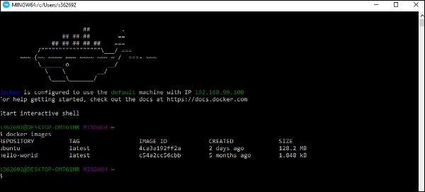

From here, we can see that we have two images − **ubuntu** and **hello-world**.

## Running a Container

Now let’s run a container in the Windows Docker host.

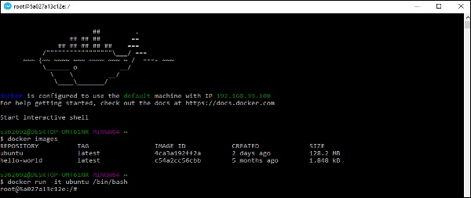

We can see that by running the container, we can now run the Ubuntu container on a Windows host.

## Listing All Containers

Let’s list all the containers on the Windows host.

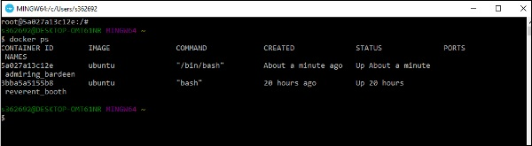

## Stopping a Container

Let’s now stop a running container on the Windows host.

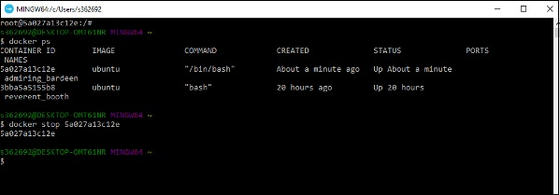

So you can see that the Docker engine is pretty consistent when it comes to different Docker hosts and it works on Windows in the same way it works on Linux.

# Docker - Configuring

In this chapter, we will look at the different options to configure Docker.

## service docker stop

This command is used to stop the Docker **daemon** process.

### Syntax

service docker stop

### Options

None

### Return Value

A message showing that the Docker process has stopped.

### Example

sudo service docker stop

### Output

When we run the above command, it will produce the following result −

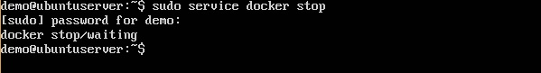

## service docker start

This command is used to start the Docker daemon process.

### Syntax

service docker start

### Options

None

### Return Value

A message showing that the Docker process has started.

### Example

sudo service docker start

### Output

When we run the above command, it will produce the following result −

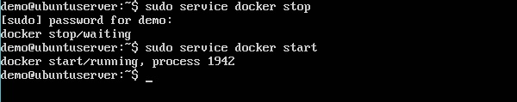

# Docker - Containers and Shells

By default, when you launch a container, you will also use a **shell command**while launching the container as shown below. This is what we have seen in the earlier chapters when we were working with containers.

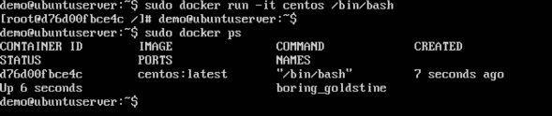

In the above screenshot, you can observe that we have issued the following command −

sudo docker run –it centos /bin/bash

We used this command to create a new container and then used the Ctrl+P+Q command to exit out of the container. It ensures that the container still exists even after we exit from the container.

We can verify that the container still exists with the Docker **ps** command. If we had to exit out of the container directly, then the container itself would be destroyed.

Now there is an easier way to attach to containers and exit them cleanly without the need of destroying them. One way of achieving this is by using the **nsenter** command.

Before we run the **nsenter** command, you need to first install the **nsenter**image. It can be done by using the following command −

docker run --rm -v /usr/local/bin:/target jpetazzo/nsenter

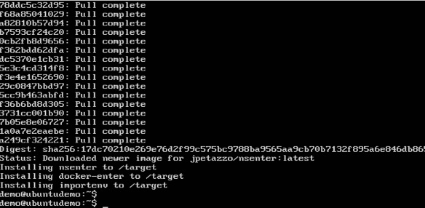

Before we use the **nsenter** command, we need to get the Process ID of the container, because this is required by the **nsenter** command. We can get the Process ID via the Docker **inspect command** and filtering it via the **Pid**.

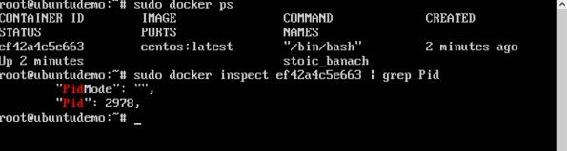

As seen in the above screenshot, we have first used the **docker ps** command to see the running containers. We can see that there is one running container with the ID of ef42a4c5e663.

We then use the Docker **inspect** command to inspect the configuration of this container and then use the **grep** command to just filter the Process ID. And from the output, we can see that the Process ID is 2978.

Now that we have the process ID, we can proceed forward and use the **nsenter** command to attach to the Docker container.

## nsenter

This method allows one to attach to a container without exiting the container.

### Syntax

nsenter –m –u –n –p –i –t containerID command

### Options

* **-u** is used to mention the **Uts namespace**
* **-m** is used to mention the **mount namespace**
* **-n** is used to mention the **network namespace**
* **-p** is used to mention the **process namespace**
* **-i** s to make the container run in interactive mode.
* **-t** is used to connect the I/O streams of the container to the host OS.
* **containerID** − This is the ID of the container.
* **Command** − This is the command to run within the container.

### Return Value

None

### Example

sudo nsenter –m –u –n –p –i –t 2978 /bin/bash

### Output

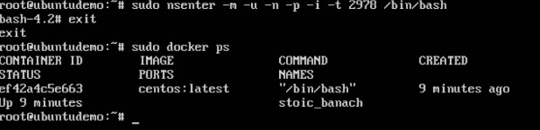

From the output, we can observe the following points −

* The prompt changes to the **bash shell** directly when we issue the **nsenter** command.
* We then issue the **exit** command. Now normally if you did not use the **nsenter** command, the container would be destroyed. But you would notice that when we run the **nsenter** command, the container is still up and running.

# Docker - File

In the earlier chapters, we have seen the various Image files such as Centos which get downloaded from **Docker hub** from which you can spin up containers. An example is again shown below.

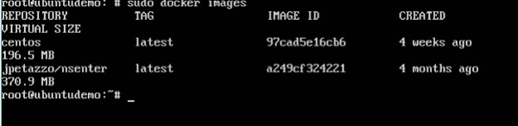

If we use the Docker **images** command, we can see the existing images in our system. From the above screenshot, we can see that there are two images: **centos** and **nsenter**.

But Docker also gives you the capability to create your own Docker images, and it can be done with the help of **Docker Files**. A Docker File is a simple text file with instructions on how to build your images.

The following steps explain how you should go about creating a Docker File.

**Step 1** − Create a file called **Docker File** and edit it using **vim**. Please note that the name of the file has to be "Dockerfile" with "D" as capital.

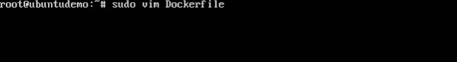

**Step 2** − Build your Docker File using the following instructions.

#This is a sample Image

FROM ubuntu

MAINTAINER demousr@gmail.com

RUN apt-get update

RUN apt-get install –y apache2

CMD [“echo”,”Image created”]

The following points need to be noted about the above file −

* The first line "#This is a sample Image" is a comment. You can add comments to the Docker File with the help of the **#** command
* The next line has to start with the **FROM** keyword. It tells docker, from which base image you want to base your image from. In our example, we are creating an image from the **ubuntu** image.
* The next command is the person who is going to maintain this image. Here you specify the **MAINTAINER** keyword and just mention the email ID.
* The **RUN** command is used to run instructions against the image. In our case, we first update our Ubuntu system and then install the nginx server on our **ubuntu** image.
* The last command is used to display a message to the user.

**Step 3** − Save the file. In the next chapter, we will discuss how to build the image.

